BUSINESS COMMUNICATION SYSTEMS COURSEWORK

MUSEUM EXHIBITION

**Toys Exhibition**

**Introduction**

The artefacts that will be exhibited in the museum is mainly targeted to growing children since the development of new technology have greatly changed the consumer tastes in toys and games; shifting the market to more electronic based entertainments. This is supported by the research by the Global Industry Analysts stating that, “Market growth is being fuelled by video, console and computer games…this group takes a greater interest in games as a popular leisure pursuit.” To attract the attention of the target audience, toys related to popular video games or movies will be displayed as they are well known and liked by children.

*(Source:* [*http://www.reportlinker.com/ci02218/Toy-and-Game.html*](http://www.reportlinker.com/ci02218/Toy-and-Game.html)*)*

Nostalgic toys would also serve to attract attention from adults who would like to share their childhood fun with their children. As supported by the key trend research by the toys association, “nostalgic parents, who in turn want to share their favourite childhood memories with their children.” The mixture of new and old toys, from the first Rubik’s cube to newest Iron Man figure, exhibited in the museum will be suitable for family or school trip where the adults would enjoy seeing these nostalgic toys and children would be interested in the more modern toys.

*(Source:* [*http://www.toyassociation.org/TIA/Industry_Facts/trends/IndustryFacts/Trends/Trends.aspx#.UnmZf9JHLTo*](http://www.toyassociation.org/TIA/Industry_Facts/trends/IndustryFacts/Trends/Trends.aspx#.UnmZf9JHLTo)*)*

**Corporate Identity**

To keep a professional look to the museum, the corporate identity of the museum must be kept consistent. This is a way of branding or trademarking to form a distinction between the museum and other competitors making the museum more recognisable. As analysed from the logo and building structures of Batcat Museum and Toys Bangkok, the main corporate colours are red, blue and grey which will be used throughout the design in order to reinforce the corporate identity.

*(Source:* [*http://en.wikipedia.org/wiki/Corporate_identity*](http://en.wikipedia.org/wiki/Corporate_identity)*)*

**Communication**

Museums are sources of information but unlike schools and classrooms, learning in museum is voluntary and self-directed so great care must be taken in the presentation of information since visitors may easily choose to ignore information delivered in an unclear or difficult to find manner. Medium of communication used, therefore, must deliver the contents of the museum and provide incentives for attending to this content.

*(Source:* [*http://infed.org/archives/e-texts/screven-museums.htm*](http://infed.org/archives/e-texts/screven-museums.htm)*)*

Since museums are audience centred rather than product lead, they must understand the visitors’ motivation and needs. In this case, all advertisements were created with primary school teachers and the students as target customers promoting educational school trips to the museum’s exhibition.

*(Source:* [*http://www.intercom.museum/documents/1-4Waltl.pdf*](http://www.intercom.museum/documents/1-4Waltl.pdf)*)*

**Database**

The information about the artefacts to be displayed in the museum is stored in a simple flat file database. A database is used instead of paperwork since it can store large amount of information in a smaller space and saves time through the use of a simple query and the correct keywords to recall information instead of having to manually look through piles of paperwork, especially when there are large amount of data. Data can also be accessed at the same time and in different places so this makes data more accessible.

*(Source:* [*http://www.life123.com/technology/computer-software/database-software/advantages-of-using-a-database.shtml*](http://www.life123.com/technology/computer-software/database-software/advantages-of-using-a-database.shtml)*)*

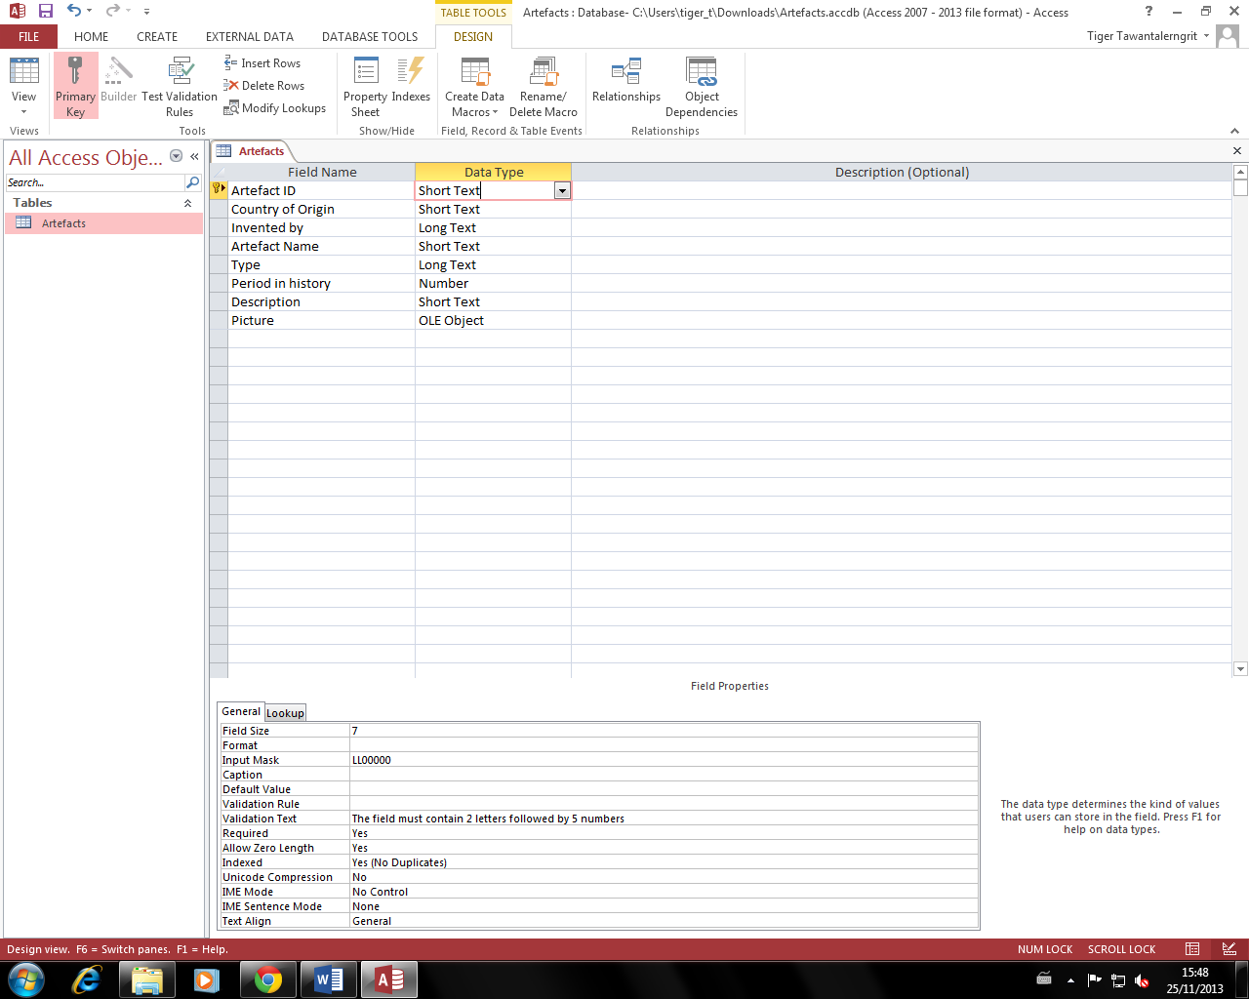

Structure:

In order to create a well-structured and efficient database, normalisation must be considered when deciding which data and fields to include in the database. This database follows the third normal form (3NF). For a database to be in the third normal form, it has to follow both the first and the second normal form which prevents redundancy of data. A well-structured database will be able to display data clearer and make finding the necessary information easier and quicker.

*(Source:* [*http://www.yourinspirationweb.com/en/database-structuring-the-normalization/*](http://www.yourinspirationweb.com/en/database-structuring-the-normalization/)*)*

1. Primary key is applied to the ‘Artefact ID’ field for validation. This ensures that no ID entered in the field is the same; preventing duplicates of records.
2. A format mask is used for the ‘Artefact ID’ field so that the IDs entered in the field have the same format. This will make sorting or filtering the data by Artefact ID easier.
3. The data type used for most of the data is text since the descriptions and names of the artefacts vary. There is a higher chance of error but verifications can then be used to check the data entered.
4. A fixed length field is used in order to reduce storage space taken up by the field. This reduced the file size as well as makes the allocation of storage space simpler since each record requires the same amount of space.

*(Source:* [*http://www.hollyfield.kingston.sch.uk/gcseit/GCSE/database.htm*](http://www.hollyfield.kingston.sch.uk/gcseit/GCSE/database.htm)*)*

1. OLE Object is used in the picture field to allow a picture file to be attached to the database. Attaching a picture will make identifying the actual artefact displayed in the museum easier.
2. The field names are simple and straightforward so that it is clear for the user about what data should be inputted into each field.

Information:

Brief information about each artefact is inputted to the database. Museums are popular amongst tourists mainly because they are interested in the history of the artefacts and a museum would be the best place that has a collection of these interesting artefacts. The reason for including a description is as suggested by Kim Kenney, curator of the [William McKinley Presidential Library and Museum](http://en.wikipedia.org/wiki/William_McKinley_Presidential_Library_and_Museum), “people want specific aspects of the object they might not notice at first glance”. Therefore, the description stored in the database can be put on display next to the artefacts on the object labels (record cards). The data type is short text !!!!!!!!!!!!!!!!!!!!!!!!!!!!!!!!!!!!!!!!!

*(Source:* [*http://en.wikipedia.org/wiki/Museum_label*](http://en.wikipedia.org/wiki/Museum_label)*)*

Data Types:

The use of data types suitable for each field will allow data to be validated since data may be entered by many people and field types may be used to make sure that data entered are in the same format and that they are the correct information.

Artefact ID:

The artefact ID is the unique field (primary key) for the database which uniquely identifies each artefact. This also ensures that there are no duplicates of records or no records are missing which prevents redundancy of data; that is, no useless data which will take up space in the database. To let the ID be in the same format for easy sorting and finding records, the input mask is set as LL00000 which means that there must be 2 letters followed by 5 numbers. If abnormal data is entered, a validation text that says, “The field must contain 2 letters followed by 5 numbers” will show as an error message so that the user knows how to correct the data.

Period in History:

The period in history field stores the information about the years in which the artefacts were first invented. Since the years contain only numbers, the field type is set as number; preventing any letters from being entered in the field. This ensures that only the correct type of data is entered in the field since years does not contain letters. The input mask is 0000 to allow only 4 numbers to be entered in the field and the validation rule is <2014 since there should not be artefacts displayed that will be invented in the future. Making sure that the information about the date is entered correctly is important for clear communication since museums should be a credible source of information for educational purposes as previously mentioned in the “Communication” section.

Since validation rules and input masks were set, they have to be tested to make sure that the rules work and will return an error message when abnormal data is entered. To do this, normal, abnormal and extreme data were entered in the field.

**Record Card**

To produce a record card, the mail merge function was used to merge the database (data source) created with the record card template (main document). Merge fields were then inputted which marks the position where data from the database are to be entered. Mail merging ensures that the format is consitent and saves time entering the data about the artefacts onto the card.

Microsoft word was used instead of the label wizard on database since it is easier to set the layout and format of the record card to make it more attractive due to the limitations of database to set decorations such as colours and borders.

Colour:

A warm orange colour is used as the background colour for the record cards based on the psychology of the warm colours, “Warm colours are some of the best colours for advertising…A colour scheme that incorporates warm colours also encourages people to linger”. This is suitable for object labels for the artefacts since it draws information to the card.

*(Source:* [*http://www.wisegeek.org/what-are-the-best-colors-for-advertising.htm*](http://www.wisegeek.org/what-are-the-best-colors-for-advertising.htm)*)*

Using a cool colour such as dark blue as the borders in contrast with the warm colour helps to create a balance between the excitement and calmness. The blue colour has a calming effect shown in the psychological properties of colour, “serene and mentally calming. It is the colour of clear communication.” The visitor can be detached from the chaotic world as they immerse in a world surrounded by toys from famous fictions.

*(Source:* [*http://www.colour-affects.co.uk/psychological-properties-of-colours*](http://www.colour-affects.co.uk/psychological-properties-of-colours)*)*

Contents:

The name of the artefact is important as it tells the reader what the object displayed is as people may recognise the artefact by its name. The record card also includes the country in which the artefacts originated in, the person or company that invented the artefact and the year in which it was first produced. There is an outline for where the picture of the artefact is to be placed which will help to clarify which artefact the record cards are giving information about.

**Webpage**

A website is created as an online advertisement for the exhibition to make people aware of the location and time of the exhibition. Nowadays, online advertising has become more popular due to wide reach of the internet making it one of the most powerful tools of advertising.

People who are interested in toys exhibitions can easily find the website using a search engine…

*(Source:* [*http://ezinearticles.com/?Purpose-of-Online-Advertising&id=1990127*](http://ezinearticles.com/?Purpose-of-Online-Advertising&id=1990127)*)*

The home page introduces the museum and uses combination of picture and choice of language to grab the reader’s attention. Since the museum is targeting primary school teachers who may want to arrange a trip to the museum, information is given about the booking for a visit at the museum.

The exhibition page informs the reader about the exhibitions currently taking place at te museum and includes the time period for the exhibition in large, bold text. Pictures of the artefacts are placed with their brief description to let the potential customers see what is to be expected at the museum.

1. The website is easy to navigate around with a navigation bar at the top of the page. Mouse-over effects are also applied to the hyperlinks and the home icon. According to a survey, “rollover effects not only add visual interest to a Web page but also improved click-through rates by approximately 30% (Kaiser, 2000)”. This interaction makes visitors feel more connected to the site.

*(Source:* [*http://www.cs.umd.edu/~mount/Indep/CHassan/navbar.htm*](http://www.cs.umd.edu/~mount/Indep/CHassan/navbar.htm)*)*

1. An anchor (bookmark) is placed at the top of the page to help the visitor quickly navigate back to the top of the page once they reach the bottom. This helps save time and the amount of scrolling required.

*(Source:* [*http://help.yahoo.com/l/us/yahoo/smallbusiness/webhosting/ghtml/ghtml-14.html*](http://help.yahoo.com/l/us/yahoo/smallbusiness/webhosting/ghtml/ghtml-14.html)*)*

1. Image

*(Source:* [*http://ethicapublishing.com/ATEOI_ch2.pdf*](http://ethicapublishing.com/ATEOI_ch2.pdf)*)*

1. Logo

**Leaflet**

Leaflets are relatively inexpensive method of communicating and a tri-fold leaflet is used in this case since it is the most common type of leaflet and can fit enough information with good spacing. The leaflet is aimed at primary school teachers which could be potential customers to create awareness of the exhibition. The information given in the leaflet also directs customers to the online website which will provide them with further information and gives the contact details that the teachers can use to arrange their visits.

Spacing:

The leaflet will have to be printed and folded into three sections with three panels on each side (tri-fold leaflet). To do this, a leaflet template in microsoft publisher was used to mark the panels so that no images or text goes over the fold as it will make

Front Panel:

The front panel of the leaflet should grab attention as soon as the leaflet is picked up and this is done by using the quote, “The largest toy museum in Asia… An exhibition gathering the most exclusice toys.”A logo of the Batcat Musuem and Toys is included on the front page to promote the brand but care is taken to not let the image overshadow the imporatant message by using a larger font for the quote.

*(Source:* [*http://www.psprint.com/resources/creating-professional-trifold-brochures/*](http://www.psprint.com/resources/creating-professional-trifold-brochures/)*)*

After successfully grabing the reader’s attention, they may turn to the smaller texts which will give them the museum’s contact information and opening hours. The text is written in smaller font as it is more important to get the message across about the exhibition at Batcat Museum than how to contact the museum.

An interesting quote by Tom Stoppard, “If you carry your childhood with you, you never become older,” is very suitable for this toy museum which target audience is both children and adults (school teachers) and this serves to persuade them to come to visit the museum and experience their childhood.

Center Back Panel:

The center back panel is another one of the first panel to be seen on the leaflet. Therfore, essential information such as map , adress and contact information which are needed for potential customers to actually come and visit the museum is placed on the back. The map is clear and includes noticable locations nearby to make it easier to find the museum. Simple and short language, “How to find us…” is positioned at the top of the page to lead the reader to the information.